Chapter 14, Problem 81.

The circuit shown in Fig. 14.98 has the impedance

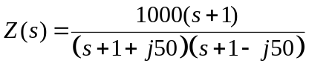

Find: (a) the values of R, L, C, and G, (b) the element values which will rais the resonant frequency by a factor of 10³ by frequency scaling.

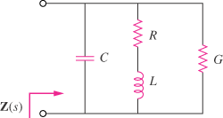

Figure 14.98
For Prob. 14.81.

